Pirate Story Ideas

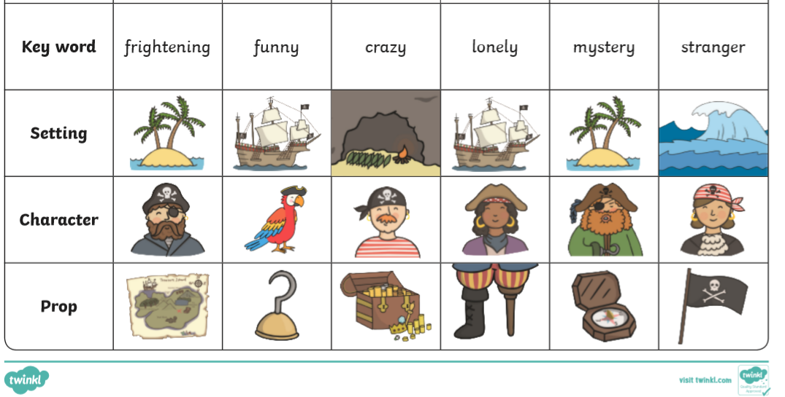
Choose a setting, character and prop. You could use the keywords to help with your ideas!

Fairytale Story Ideas

Choose a setting, good character, bad character and prop.

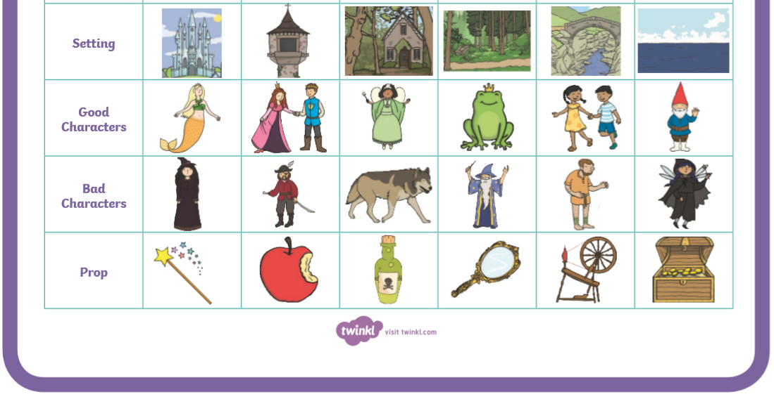

Superhero Story Ideas

Choose a setting, good character, bad character and prop.

