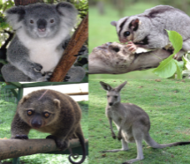
Physical development- fine motor and gross motor skills
Activity for 3-4s | Draw some lines on paper- zig-zags, wavy, straight. Use scissors to cut the lines, or cut images from used catalogues/brochures.
Modifications for 2s and 3s | Rip paper from big sheets to small (used newspaper or scrap paper will do!)  Let your child stick pictures you have pre-cut.
Extension ideas | Use the images to make a story or to make a plan for a bedroom/holiday. Make a landscape with animals that you cut out- design the background.  Develop skills with manipulating and managing sticky tape.
Focus on language development | Speaking: Describing and explaining  Listening/attention: Following instructions  Understanding: 2-part instructions, “First…then…”
Information for parents | Scissor skills support drawing and writing control and skills.  Creating and retelling stories is a crucial skill in Reception Class.
Cross-curricular links | Maths: Shapes and sizes Literacy: stories Personal/social: confidence  Understanding: using tools/thinking about places/animals/homes  Expressive: ideas and design
End of nursery ‘goals’ for those going to Reception in September | - Good pencil and scissor control  - Connect and join materials  - Represent ideas  - Language of measures

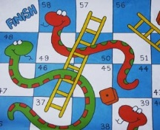
Personal, Social and Emotional development
Activity for 3-4s | Play a game/ board game/card game (such as Snap!)
Modifications for 2s and 3s | Play hide-and-seek or a treasure hunt with a favourite toy
Extension ideas | Play ‘I-Spy with my little eye’ (using sounds), ‘I went to the shops..’ , Jane’s (memory) game (explanation below!)
Focus on language development | Speaking: Using tenses –past/future  Listening/attention: Respond to directions  Understanding: Sequences
Information for parents | Turn-taking, waiting, sharing and not winning or being first are important life-skills for school! (Even though it’s difficult- it builds resilience).  Jane’s memory game- Make a selection of 5-7 items. Let your child have a good look. Cover them. Remove one item from under the cover. Uncover them. Can your child identify the missing item?
Cross-curricular links | Maths: Counting/numbers/same/position/memory  Literacy: Sounds/words/sequences
End of nursery ‘goals’ for those going to Reception in September | - Co-operative play  - Respond to others’ feelings  - Friendly behaviour  - Maintain attention

Mathematical Development
Activity for 3-4s | Go around the house and collect all the square, circular, rectangular, triangular items you can find. Sort them into groups and talk about how you know it’s a triangle. What about bigger items around the house?
Modifications for 2s and 3s | Play with blocks/bricks Do jigsaw puzzles  Cut shapes from paper/card use them to make patterns or collage
Focus on language development | Describe and explain Learn new words- sides/corners/points  Increase vocabulary Use comparative language
Extension ideas | Do the same with 3-D shapes  Make a shape pattern Can you make a repeating pattern?
Cross-curricular links | Literacy: draw the shapes you found Personal/social: having a go  Understanding: Explain thinking, listen to the ideas of others, change their mind
Information for parents | Being able to recognise and visually discriminate between shapes helps children when it comes to recognising numbers and letters.
End of nursery ‘goals’ for those going to Reception in September | - Describe the features of a shape.  - Use everyday language, “It’s like a pizza!”  - Recognising and creating patterns.

Literacy Development: Writing Name
Activity for 3-4s | Can you write your name with a capital letter at the beginning and then all small-case?
Modifications for 2s and 3s | Lots of drawing, painting, chalks on the floor in the garden, playdough activities.
Extension ideas | Can you write your surname? Or ‘Mum’, ‘Dad’, ‘To’, ‘Love’, ‘From’ or the names of other family members?
Focus on language development | Talk about the way in which you form a letter- the position you start and the direction the pen goes. Most ‘start at the top’ (except d and e) and go ‘straight down’ or ‘towards you’ only a few ‘go away from you’ (e, x, z)
Information for parents | Children often draw in a clock-wise direction- it is harder to go right to left (anti-clockwise)- even harder is to ‘retrace a vertical line’ like in ‘m’ that starts at the top, goes down, then back up the same line to the top and over and over.
Cross-curricular links | Personal/emotional: Persistence Physical: Pen control  Maths: Direction, shape, position Expressive: Tools for purpose
End of nursery ‘goals’ for those going to Reception in September | - Write their name so that it is recognisable  - Write other letters/letter-type shapes  - Draw a person with head, body and some detail

Literacy Development: Reading 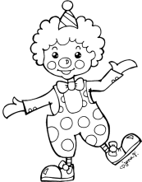
Activity for 3-4s | Make silly rhyming names or words- we do this at the end of storytime and the children like it very much! Make a silly rhyme of someone’s name in your family- for example, “Pusan, Dusan, Fusan, Lusan!” and the child has to guess the name, “Susan!” See if your child can rhyme a name or word into a silly string. Make nonsense words!
Modifications for 2s and 3s | Singing songs like ‘The wheels on the bus’ or ’Old McDonald had a farm’ and our sound songs allow children to hear and make different sounds.
Extension ideas | Rhyme simple words like- cat, dog, tin, bun, cap to make new words and silly/nonsense words.
Focus on language development | Following instruction Focus on the main word Explore and play with words  Organise and modify words
Information for parents | Being able to hear the initial sound in the word and then words that rhyme will help the children with their writing in Reception Class.
Cross-curricular links | Personal/emotional: Trying new things  Understanding: Notice similarities differences and patterns  Expressive: Make up own songs and rhymes
End of nursery ‘goals’ for those going to Reception in September | - Linking some sounds to letters  - Hearing rhymes  - Recalling rhymes

Understanding the World 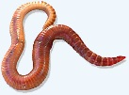 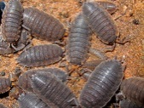 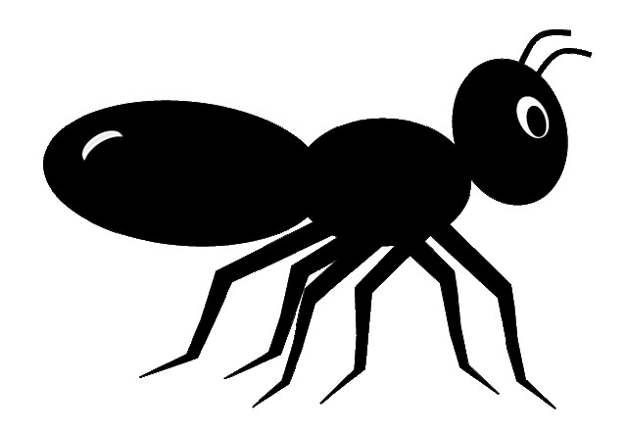
Activity for 3-4s | Find a minibeast in your garden or on your daily walk. Treat it gently and put it back outside after you have had a close look and good chat about it. Notice details and features and observe behaviours.
Modifications for 2s and 3s | Look at some pictures and sing songs such as ‘Insey Wincey spider’, ‘There’s a worm at the bottom of my garden’, ‘I’m a funny little caterpillar’.
Focus on language development | Does your child ask ‘how?’ and ‘why?’ questions? Can they answer them if you ask them? Do they use ‘because’?
Extension ideas | Can they explain their thinking and give reasons? Can they argue if they disagree with you? Do they change their mind if you convince them?
Information for parents | Reasoning and explaining language is very important for maths in Reception Class.
Cross-curricular links | Personal/social: Collaboration, listening to others  Literacy: Can you draw a picture/record you ideas?  Maths: Count how any legs/body parts. Talk about shapes/sizes/patterns.  Expressive: Can you make up a minibeast song?
End of nursery ‘goals’ for those going to Reception in September | - Care of living things  - Explain thinking  - Notice features  - Share ideas

Expressive Arts and Design
Activity for 3-4s | Make a landscape for your favourite small-world toy or character- for example, a dinosaur land, a moonscape, a beach party or a jungle hide-out. Use boxes, egg cartons, paper, fabric, foil, towels etc.
Modifications for 2s and 3s | Place a green towel or t-shirt down to represent grass for farm or wild animals, use a blue towel for water.
Extension ideas | Design and make a space-ship. Create story lines.
Focus on language development | Think about planning language- ‘I need..’. Plan sequences-‘First…then…after...’ Explore ideas- ‘It could be…’ ‘How about…?’ ‘Maybe…’
Information for parents | Using representation (pretending)- “This is my jungle” - is important because we use symbols to ‘stand for’ letter sounds an number amounts.
Cross- curricular links | Personal/social: Solve problems  Physical: Manipulate materials, use tools, combine materials  Literacy: Representing. Draw your story.  Maths: Measures of size, height, length.
End of nursery ‘goals’ for those going to Reception in September | - Represent people, objects and experiences  - Combine materials  - Use experiences  - Organise

