Morning | Are they still in a nappy during the day? Is this a good time to try potty training?  Do they help with dressing- can they have a little try?  Do they feed themselves?  Help with tooth-brushing- can they do it by themselves?  Can they help to choose their clothes?  Songs to help talking and language:  This is the way we wash our hands/brush our teeth…  If you’re happy and you know it…  (YouTube has examples of these songs if you’re unfamiliar with them)
Afternoon | Try new fruits or vegetables- they say you have to present them over 50 times! Remember to let your children see you eating these things.  Play with toys together-talk about what you are doing with the toys and describe what your child is doing.  Count at every chance- stairs/snacks/jumps.  Get some energy out! Do some dancing or exercise! If you have a garden- do some gardening, or play out. If not, have you been going out for your 1 hour’s exercise?
Evening | Can they help with dinner? Give them a bowl to wash the salad/potatoes.  Are you phoning friends/relatives? Can they have a little chat on the phone?  Play in the bath- count fingers and toes as you dry them.  Ask them where their mouth/eyes/nose/ears are. Can they find yours?
Bedtime  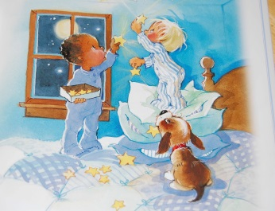 | Sing favourite songs before bed- Twinkle, twinkle/Baa baa black sheep/Wheels on the bus/Old McDonald had a farm/Row your boat  Talk about the colours and patterns on their pyjamas  Read a story before bed. Talk about the pictures. Learn new words from the pictures.

