Morning | Look out of the window- what is the weather like today?  What day of the week is it? Make a calendar of the month and cross off the days.  Can they help to choose their clothes? Why do they like those clothes? Why have they chosen those? Do they match the weather? How? Can they dress themselves?  Make something together- with junk/lego/bricks/craft/cooking- or make up a new song or dance! Video it.  Create a drawing about last night’s story/write a letter/write a shopping list.
Afternoon | Try new fruits or vegetables- describe how they look/feel/taste. Remember to let your children see you eating these things.  Count at every chance- stairs/snacks/jumps/cutlery.  Get some energy out! Do some dancing or exercise! If you have a garden- do some gardening, find some bugs to look at and talk about, or play out. If not, have you been going out for your 1 hour’s exercise?  Sing some of our phonics/letter songs.  Sing some of our number songs.
Evening | Can they help with dinner? Can they butter the bread, peel the carrots or wash the salad? Are they trying new foods?  Are you phoning friends/relatives? Can they have a chat on the phone?  Play in the bath- talk about which container would hold the most/least water. Test it. Talk about it.
Bedtime  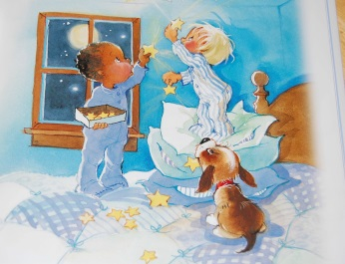 | Sing favourite songs before bed- use our song sheets.  Read a story before bed. Talk about the pictures. Follow the text with your finger as you read. Find the first letter of your child’s name, “Look, there’s your…”

