Early Reading Policy-
Written June 2022

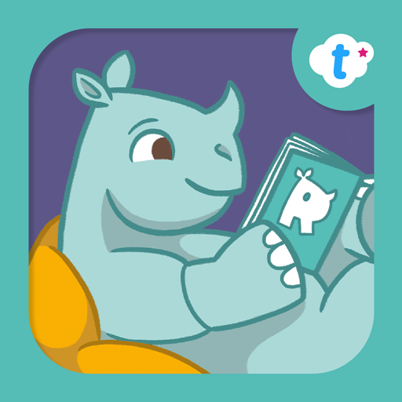
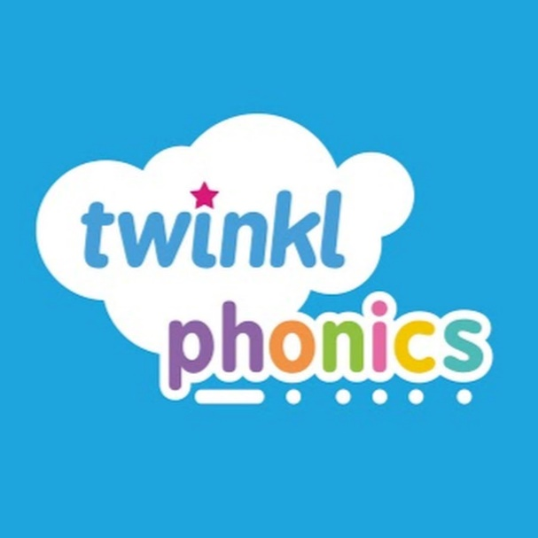

Early Reading Policy- Written June 2022

Rational
The best practice for beginner readers provides them with a rich curriculum that fosters all four interdependent strands of language: speaking, listening, reading, and writing which are prime communication skills that are central to children's intellectual, social, and emotional development.
Attention needs to be given, right from the start, to promoting speaking and listening skills to make sure that children build a good stock of words, learn to listen attentively, and speak clearly and confidently. Engaging young children in interesting and worthwhile pre-reading activities paves the way for a good start on systematic phonic work by the age of five.
Children need to be supported in the transition from learning to read to ‘reading to learn’. This must go hand in hand with encouraging all children to see themselves as readers and to value books as a source of pleasure and enjoyment as well as for information. Children need to develop a positive approach to reading and value this as a lifelong skill.

At Old Oak Primary school, we follow the TWINKL phonics scheme in its entirety. This scheme is DFE approved. We piloted this from Easter 2022, after extensive and collaborative professional dialogues and observations from an early year’s consultant working in reception, we will adopt this scheme fully as of September 2022.

We also follow the Centre for Language in Primary Education ‘Power of Reading’ scheme which fosters a love of reading, using high quality texts and our English curriculum is taught through these texts.
Each year group uses the ‘Language Structure’ document when rehearsing for writing and using key phrases and sentence structures for each text type.

Our aims
• To ensure that a rich and relevant language curriculum is provided in the Foundation Stage and Key Stage 1.
• To provide a rich language environment which develops children’s language comprehension skills through speaking and listening.
• To support teachers in developing an understanding of the progression of phonics acquisition.
• To use a systematic and progressive approach to the teaching of phonics.
• To ensure that phonics is taught in an appropriate and motivating way that engages all children.
• To monitor the progression of children in phonics acquisition and to plan their next steps for learning according to their individual needs.
• To inform and engage parents/ carers in the support of their child’s early reading development (parent meetings, reading with your child, phonics workshops and training).
• To encourage children to become both independent and co-operative learners through working as individuals and as group members.

Learning environments

At Old Oak we aim to provide a range of quality literacy experiences and a print rich physical environment both inside and, where possible, outside as this facilitates and supports learning.
Each class should therefore have:

• A range of environmental print including a display alphabet and high frequency words taken from the twinkl resources.
• An attractive and stimulating book area which may include a focus. .
• Easy and independent access to support materials.
• Activities to promote fine and gross motor skills.
• A themed role-play area incorporating reading and writing materials in Nursery and Reception.

The Simple View of Reading

There are two dimensions to reading – ‘word recognition’ and ‘language comprehension’. Successful reading demands both word recognition and the ability to comprehend what has been read.

The Teaching of Phonics
Intent

The use of phonics is one of the many skills needed to be able to be a reader and writer. We aim to teach high quality phonics to ensure the children have the best start possible in reading and writing. The learning of phonics is the beginning of children’s body of knowledge, skills and understanding that are an essential part of learning to read.
In order to read and understand texts, children must learn to recognise/decode the words on the page. Good quality phonics teaching allows the child to be secure in the skills of word recognition and decoding which allows children to read fluently. This will result in children being able to read for pleasure and will allow them to move onto developing higher order reading for meaning skills.

The curriculum

Our children are provided with a variety of opportunities to develop and extend their phonics skills in and across Nursery, Reception and Key Stage 1. It will also be continued into Key Stage 2, where necessary, to support those children who do not yet have the phonic knowledge and skills they need.
Discrete phonics lessons take place daily across Reception and Key Stage 1. Some children will have daily phonics in year 3- see above. They follow the cycle of ‘Assess, Teach, Practise, Apply’ to ensure that children are consolidating phonic knowledge and skills over time and that they are able to apply them in context. Consequently, wherever possible, links between phonics knowledge and understanding are made to learning in both Reading and Writing. These lessons proceed at pace and incorporate a wide range of practical and interactive learning opportunities to engage the children.
Learning opportunities are carefully chosen to ensure that children develop their skills in aural discrimination and phonemic and rhyme awareness, blending and segmenting as well as grapheme-phoneme correspondence

In the Nursery:

• Phase 1 activities take place across the year. There is a mixture of aspect 1 – 5 activities/ learning. Initially, new activities are adult directed and later become child initiated.
• If children are developmentally ready, we will start Phase 2.
• The term prior to transferring from the Nursery to Reception, Aspect 6 and 7 are the focus of adult directed activities.

Transition and early-stage readers in Reception:

During the settling in period, the daily phonics session emphasises Aspect 6 and Aspect 7 of Phase 1.
• Twinkl mnemonics are used in the systematic teaching of phonics following the sequence as set out in the Twinkl trajectory for the teaching of phonics.
• Each child is involved in a guided reading session at least once a week.
• At the very early stages of reading, children take part in group work focusing on the teaching of phonics, application of newly acquired phonic strategies, developing word recognition and language comprehension skills.
• All children have the opportunity to practise new knowledge through appropriate provision in the classroom. This includes taking home a reading book that is within their phonic phase of learning- these are digital books. They also take home a book to read for pleasure book too. This book nay come from the class library or the whole school library.

Reception and Year 1:

• Children are ability grouped for the discrete teaching of phonics after a whole class session and dependent on needs, at other times of the day to complete discrete accelerated phonics.
• Children are grouped based on an assessment of phonic phase.
• Children have the minimum of one guided reading session a week.
• Guided reading sessions are planned with clear learning intentions and a record of achievement against the learning intention made at each guided reading session. Opportunities to reinforce discrete phonics teaching are identified. These are recorded in the guided reading folder
• Guided reading texts match a child’s phonic phase.
• Some guided reading in Reception and Year 1 is adapted to meet the needs of less able children. Here the emphasis is on Phase 1. We also use phonic games, plastic letters and magnetic boards, CVC pictures and phonic boards to teach early phonic skills in smaller groups than usual.
• There is a continued emphasis on Aspect 6 and 7 of Phase 1.
• Children also take home ‘read together’ texts. This will include a learning for Pleasure book and a book from the band reading scheme. This supports the development of comprehension and reading for enjoyment.

Year 2:
• In line with statutory requirements, children who do not meet expected standards revisit the phonics curriculum of Year 1 and are targeted for intervention.
• The systematic teaching of phonics continues to follow the sequence as set out in the Twinkl trajectory for the teaching of phonics.
• Once children are proficient in their use of phonics to decode words, the development of comprehension strategies becomes the focus for teaching.

End of Year Age Related Expectations

By the end of EYFS children should:

• Read and understand simple sentences.
• Use phonic knowledge to decode common words and read them aloud accurately.
• Confidently read by sight the Stage 2 and 3 common exception words as stated in the twinkl scheme.
• Use phonic knowledge to write words in a way which matches how the sounds are said.
• Write some irregular common words.

By the end of Year 1 children should:

• Apply phonic knowledge and skill as the prime approach to reading unfamiliar words that are not completely decodable
• Read many frequently encountered words automatically
• Read phonically decodable three-syllable words
• Read a range of age-appropriate texts fluently
• Demonstrate understanding of age-appropriate texts
• Read decodable words that end –s, –es, -ing, -ed, -er, -est
• Say the correct sound to grapheme for all the 40+ phonemes up to Stage 5

By the end of Year 2 children should:
• Read accurately most words of two or more syllables.
• Read most words containing common suffixes.

Effective practice in phonics- please see the phonics folder saved on T drive under curriculum phonics for detailed planning formats and planning overviews.

At Old Oak:

• A daily phonics session takes place for approximately 15 – 20 minutes.
• The session is pitched at the appropriate phase, considering the different ability levels within the group.
• The session reinforces and builds on recent learning, using the Revisit, Teach, Practise, Apply model.
• The session is engaging, pacey and follows the Twinkl session structure.
We use the robot arm- Twinkl- to segment and blend.
• The teaching of phonics is underpinned by a synthetic approach to blending phonemes in order all through a word to read it, and segmenting words into their constituent phonemes to spell them.
• We make clear that blending and segmenting are reversible processes.
• Children can practise new knowledge through appropriate provision in the classroom. This includes taking home a reading book that is within their phonic phase of learning.
• Throughout the day, teachers’ model the application of phonic skills taught (shared and modelled reading and writing).
• Other opportunities are planned, beyond the discrete session, for children to apply their phonic knowledge and skills in reading and writing for real purposes across the curriculum.
• The discrete teaching of phonics at Reception and Key Stage 1 is recorded on the weekly planning overview from Twinkl- this is displayed in the classroom and annotated accordingly throughout the week.
- On the T drive, the handbook, trajectory, and weekly session overview is saved. The Twinkl site gives access to all resources and session plans.
• More experienced members of staff support less experienced teachers to develop the teaching of phonics. Staff also use the training sessions provided by twinkl to ensure they are confident in delivery.
• We teach the actions and rhymes that follow the twinkl way. .
• Flashcards are used as a quick warm up to refresh and rehearse previous sounds for each phase. This is differentiated for each year group.
• Monkey Reading Records are sent home to support parents in helping their children read and write ‘tricky words’.
• Children take home a reading book at their phonic phase. This is changed twice a week.
• They also take home ‘read together’ texts. This will include a Reading for Pleasure book from the class library or the whole school library banded reading scheme. This supports the development of comprehension and reading for enjoyment.

Assessment and Tracking

Pupils’ phonic acquisition is assessed half termly following the Twinkl assessment sheets.

. This supports teachers to:
o Group pupils
o Identify the tricky graphemes that require additional teaching
o Move pupils on in their learning.

High levels of communication between all staff delivering phonics ensures that groups or individuals experience precision teaching, highly matched to children’s needs when this is required.

Early Intervention and Catch-up

At Old Oak, we target language development at the earliest point in a child’s development:
• The ICAN progression tool assessment tool is used to identify vulnerable pupils for additional language support in the Nursery and reception.
• At Year 1 and beyond, Children who are working within Phase 2 of the phonic phase of acquisition and who have been identified through on-going assessments as needing additional support in order to access the learning in Phase 3, Phase 4 and 5 are targeted through a small group interventions.
• At Key Stage 2, there is a trajectory that supports catch-up.
We use Talk Boost to provide children with timely interventions
A specialist speech and language TA works in class supporting children in R, and Years 1 and 2.
• We organise parent workshops so that parents understand how they can support their children’s learning.

Application Opportunities

In addition to the opportunities incorporated as part of the discrete phonics teaching session, children are given substantial practice in applying phonic knowledge to the process of reading and writing at other points in the school

Guided reading (should last no longer than 15 minutes across Reception and Key stage 1)

The format for guided Reading-
Pre-read tricky bits that might stilt children’s decoding fluency (use a writing wedge or board to work directly with the small adult led group).
- Have a clear learning intention and follow this through when hearing each child read a section of the book independently.
- Each child should read the book independently (and then again, or to their friend). We use a lollipop stick as this enables the adult to visually note how children are reading.
- Have an additional activity for children who have finished before you are ready, e.g. draw and name your favourite character. But keep the session short and on task.
- Use AFL and record any scaffolds that need to be put in at the next read for this group.
- Keep to a clear time limit to avoid children becoming distracted. Decide the minimum number of pages that should be read.
- You might also put in a short plenary focused on how children decoded certain words and what meanings they found.

Shared Reading –

Every day we model the decoding processes through interactive resources and high-quality reading materials. Sometimes the texts link to learning in other areas of the curriculum.

• Reading with individual children –

We believe that hearing individual children read remains an important part of our job. For many of our children, the adults in the school fulfil the role of parents in encouraging and monitoring their children. Children who are not making sufficient progress in reading are targeted for 1:1 reading with a teacher. A record is maintained through the individual reading card.

Tricky Words

If the word is decodable at the phase the child is working in, they decode it. If not, the word is a ‘tricky word’. Children are taught to decode and spell common ‘tricky words. We do this by:
• Identifying tricky words on the phonic trajectory thus ensuring that the tricky words taught are appropriate to a child’s level of progress.

• Introduce ‘tricky words’ by identifying the letters that do and do NOT correspond with the sounds that children know. For example: -

Oral segmenting with robot arms- Twinkl
s a i d
. ___ .
We know /s/ and we know /d/ but the /ai/ is the tricky bit.
It says /e/ So the word says s e d (orally segment)

Using flash cards once a ‘tricky word’ has been introduced.
• Displaying common exception words in the environment.
• Including ‘tricky words’ on spelling lists.
Words are displayed in the classroom and using the twink resources.

Reading schemes

All digital sound books which are sent home are phonetically decodable and matched to our phonic trajectory, which is based on the sequence of learning set out in Twinkl. The guided reading books are hard copies that the children use that are the same as the digital books.
• The reading schemes we use:
Rhino Readers from Twinkl

Access to a Range of Quality Texts

The whole class have easy access to baskets of books that is appropriate to their reading level and are engaging. These are changed by the teacher regularly. Book selection is important and is based on children’s stage of learning interest, potential engagement with the content and ensures a wide coverage of genres. It is also an opportunity to introduce children to ‘high interest’ texts that they may enjoy, that they are able to read, but that aren’t necessarily part of the reading scheme as in the sounds they understand.

Core texts

High quality children's literature is at the heart of the reader experience at Old Oak hence we follow the CLPE- Centre for Literacy in Primary Education- Power of Reading. From Nursery onwards, it is underpinned by the core book approach. We have our own list of core texts. In EYFS, core texts are used as the basis of much of the Communication, Language and Literacy work undertaken by children; they are immersed in the world of each text and are provided with experiences which encourage them to 'live' the text in tangible ways that spark creativity and imagination.

Parental engagement

Parental partnership and home support is a very important part of early reading. The Literacy team and teachers from EYFS to Year 2 collaborate to provide a variety of opportunities for parents to better understand how they can best help their child to make progress in reading.
When children experience phonic difficulties, we work closely with parents through targeted discussion, workshops, and specially prepared phonic materials. Workshops for parents enable us to respond to the needs of individual parents.

In Year 1, all parents are encouraged to participate in a workshop in the autumn term where they learn phonics games that they can play at home with their children. Parents particularly appreciate the resources which they are given to support them to do this. Twinkl offers training and support for families so these are also used.

On occasion, some parents require 1:1 support, which we have the capacity to provide. This is particularly true if their child is experiencing phonic difficulties. In such cases, we work closely with parents through targeted discussion and early intervention workshops, where we share activities and materials that they can use to help supplement the learning that happens in class.

Responsibilities- Please read in conjunction with the EYFS Phonics lead job description, the Key stage one Phonics lead job description and the strategic phonics lead Job description- this is the SLT staff member.

The KS1 English Coordinator is responsible for phonics throughout the school with support from SLT- strategic phonics lead and the EYFS early phonics lead.

This includes:
• Ensuring continuity and progression from year group to year group and the transition from each phase.
• Providing all members of staff with guidelines and non-negotiables to show how aims are achieved and how the variety of all aspects of phonics is to be taught
• Advising and supporting colleagues in the implementation and assessment of phonics in their phase of the school.
• Assisting with the requisition and maintenance of resources required for the teaching of phonics, within the confines of the school budget.
• Monitoring the quality of teaching and learning in phonics across the phase.

Teachers are responsible for:

Ensuring progression in the acquisition of phonic knowledge and skills with due regard to the National Curriculum for English and the non-negotiables for each phase.
• Developing and updating skills, knowledge and understanding of phonics
• Identifying needs in phonics and adapting planning to suit all children.
• Keeping appropriate on-going records
• Planning effectively for phonics, liaising with the Phonics Leader for their phase when necessary
• Informing pupils and parents of their progress, achievements, and attainment

